NAME: Yash Shah

CLASS: TE Comps BATCH: D

UID NO: 2018130049

Lab Assignment 1

# AIM:

To study different types of physical layer wired/wireless connections

# THEORY:

The physical layer in the OSI Model is the lowest layer and is used for transmitting data in its basic form: bit-level. The transmission medium can either be wired or wireless. Physical layer components in a wired model include cables and connectors that are implemented for carrying data from one place to another. Data is transmitted in the form of electromagnetic signals, which translates to a stream of bits. Over the past few years, there has been rapid growth in wireless data transmission as well. Due to the availability of internet, Wi-Fi and Bluetooth communications are becoming a norm.

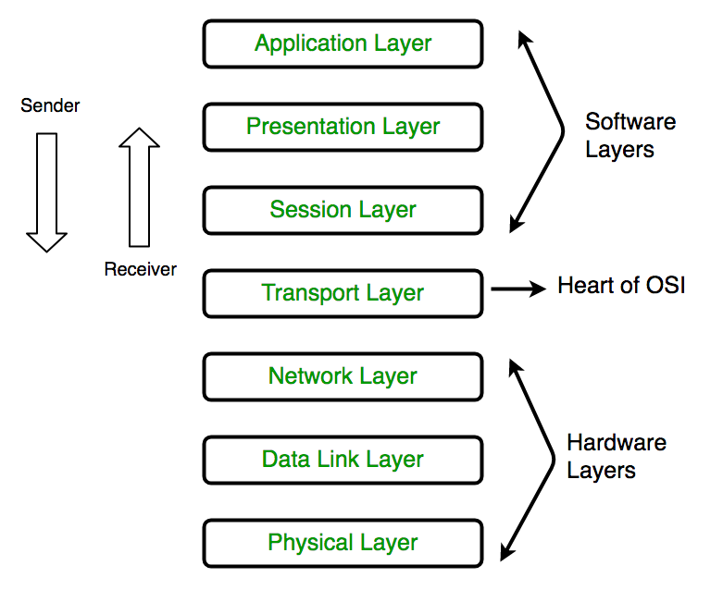

### The functions of the physical layer are -

1. Bit synchronization: The physical layer provides the synchronization of the bits by providing a clock. This clock controls both sender and receiver thus providing synchronization at bit level.
2. Encoding and Signalling**:** How are the bits encoded in the medium is also decided by this layer. For example, on the coppar wire medium, we can use differnet voltage levels for a certain time interval to represent '0' and '1'. We may use +5mV for 1nsec to represent '1' and -5mV for 1nsec to represent '0'. All the issues of modulation is dealt with in this layer.
3. Bit rate control**:** The Physical layer also defines the transmission rate i.e. the number of bits sent per second.
4. Physical topologies**:** Physical layer specifies the way in which the different, devices/nodes are arranged in a network i.e. bus, star or mesh topolgy.
5. Transmission mode: Physical layer also defines the way in which the data flows between the two connected devices. The various transmission modes possible are: Simplex, half-duplex and fullduplex.

**WIRED CONNECTIONS**

There are 3 major types of Wired Media:

* Coaxial Cable
* Twisted Pair Cable
* Optical Fibre Cable

1. **Coaxial Cable**

It has an outer plastic covering containing 2 parallel conductors each having a separate insulated protection cover. Coaxial cable transmits information in two modes: Baseband mode(dedicated cable bandwidth) and Broadband mode(cable bandwidth is split into separate ranges).

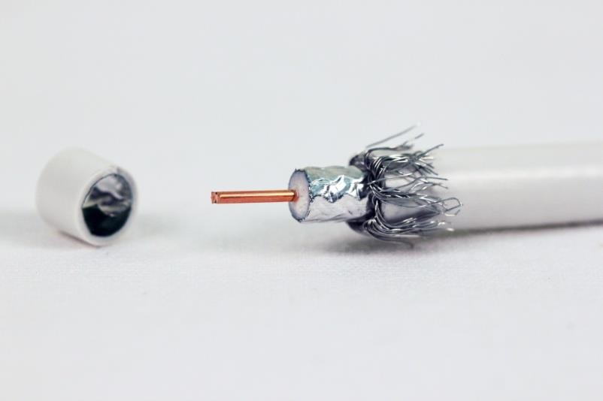

[Coaxial cable](https://www.ppc-online.com/broadband-coaxial-cable) is commonly used by cable operators, telephone companies, and internet providers around the world to convey data, video, and voice communications to customers. It has also been used extensively within homes.

It has been around for a long time as a technology (since the early 20th century) and has many singular advantages for reliable, accurate transmission.

Advantages:

* High Bandwidth
* Better noise Immunity
* Easy to install and expand
* Inexpensive

It also has limitations that will cause it to be replaced in some cases by [fiber optic cable,](https://www.ppc-online.com/blog/4-factors-that-influence-how-long-your-fiber-network-will-last) [category](https://www.ppc-online.com/category-cable) [cable](https://www.ppc-online.com/category-cable) or, sometimes, by wireless signals.

Disadvantages:

* Single cable failure can disrupt the entire network.

**Specifications**

* Range: Up to 500m
* The transmission speed of coaxial cable is 10Mbps (megabits per second), and they offer 80 times more transmission capacity than twisted pair cables.

**Scalability**

It is mainly used in LAN

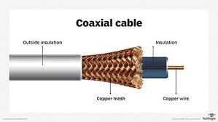

1. **Twisted Pair Cable**

Twisted pair is a physical media made up of a pair of cables twisted with each other. A twisted pair cable is cheap as compared to other transmission media. Installation of the twisted pair cable is easy, and it is a lightweight cable. The frequency range for twisted pair cable is from 0 to 3.5KHz. It can either be a shielded or unshielded twisted pair.

## Unshielded Twisted Pair Cable

It consists of two insulating copper wires (1mm thick). The wires are twisted together in a helical form to reduce electrical interference from a similar pair. Identification is the reason behind colored plastic insulation.It has high-speed capacity. Bandwidth is low when compared with Coaxial Cable. It provides less protection from interference. The commonly used UTP cables is Cat5, Cat5e, Cat6, Cat6a and Cat7/

**Scalability**

Higher grades of UTP are used in LAN technologies like Ethernet.

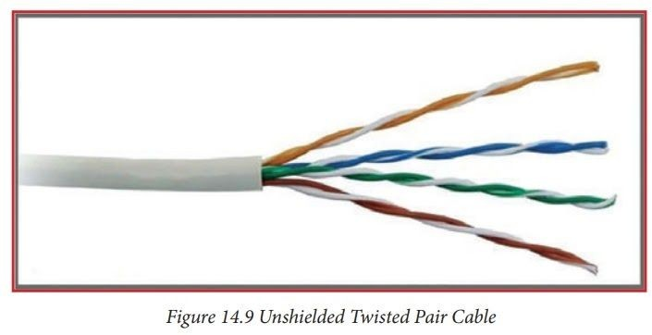

* Shielded Twisted Pair Cable

This cable has a metal foil or braided-mesh. Electromagnetic noise penetration is prevented by a metal casing. Shielding also eliminates crosstalk. It is faster than unshielded and coaxial cable.

Advantages:

* + - * + It can be used for Analog or Digital transmission
        + It increases the signaling rate.
        + It eliminates crosstalk.

Disadvantages:

* + - * + It is difficult to manufacture

**Specifications**

Range: 100m

Modulation: It uses line coding technique. Line coding is the process of converting digital data to digital signals. By this technique we converts a sequence of bits to a digital signal. At the sender side digital data are encoded into a digital signal and at the receiver side the digital data are recreated by decoding the digital signal.

**Scalability**

It is scalable in LAN architecture.

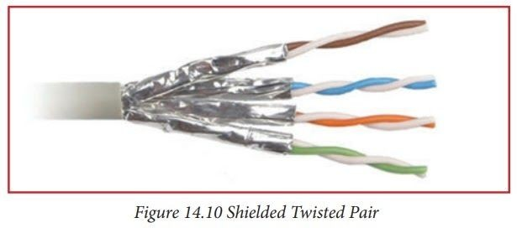

1. **Fiber Optics Cable**

[Fiber optic cable,](https://www.fs.com/c/fiber-optic-cables-209) also called as optical fiber cable, is a type of Ethernet cable which consists of one or more optic fibers that are used to transmit data. Fiber optic cable transmits data as pulses of light go through tiny tubes of glass. The transmission capacity of optical fiber cable is 26,000 times higher than that of twisted pair cable.

Fiber optic cable can be divided into [single mode fiber (](https://www.fs.com/c/os2-9-125-single-mode-duplex-897)SMF) and multimode fiber (MMF).

**Single mode optical fiber** has a small core, and only allows one mode of light to propagate at a time.

**While multimode fiber** cable comes with a larger core and is designed to carry multiple light rays or modes at the same time.

**Specifications**

* Range: Up to 80km.
* Bandwidth up to 4700MHz. Available for home use in speeds up to 2 Gbps (2000 Mbps). Business Internet available in much faster speeds.
* Modulation

An optical modulator is a device which is used to [modulate](https://en.wikipedia.org/wiki/Modulation) [a beam of light.](https://en.wikipedia.org/wiki/Light_beam) Depending on the parameter of a light beam which is manipulated, modulators may be categorized into amplitude modulators, phase modulators, polarization modulators etc. Often the easiest way to obtain modulation of intensity of a light beam, is to modulate the current driving the light source, e.g. a [laser diode.](https://en.wikipedia.org/wiki/Laser_diode) This sort of modulation is called *direct modulation*, as opposed to the external modulation performed by a light modulator. For this reason light modulators are, e.g. in [fiber optic communications,](https://en.wikipedia.org/wiki/Fiber_optic_communications) called *external light modulators*.

**Scalability**

It is scalable in CAN architecture.

**Schematic View**

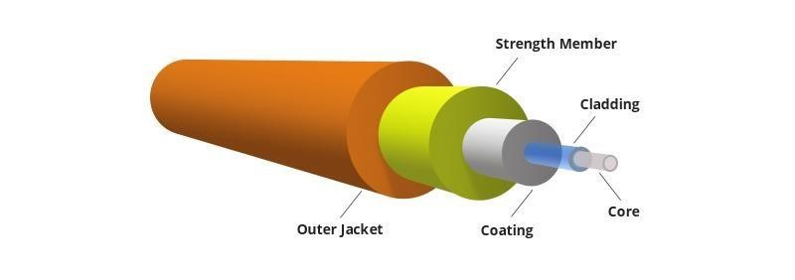

1. **USB**

Universal Serial Bus (USB) is an industry standard that establishes specifications for cables and connectors and protocols for connection, communication and power supply (interfacing) between computers, peripherals and other computers. A broad variety of USB hardware exists, including several different connectors, of which USB-C is the most recent.

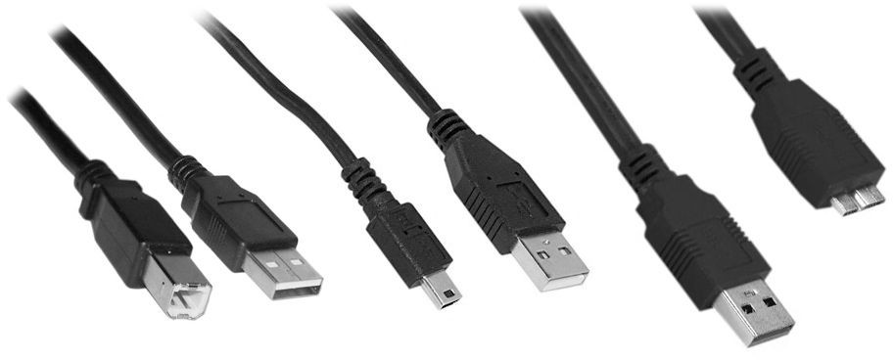

Released in 1996, the USB standard is currently maintained by the USB Implementers Forum (USB-IF). There have been four generations of USB specifications: USB 1.x, USB 2.0, USB 3.x and USB4.

# **Specifications**

* Range:

The USB 1.1 standard specifies that a standard cable can have a maximum length of 5 meters (16 ft 5 in) with devices operating at full speed (12 Mbit/s), and a maximum length of 3 meters (9 ft 10 in) with devices operating at low speed (1.5 Mbit/s).

USB 2.0 provides for a maximum cable length of 5 meters (16 ft 5 in) for devices running at high speed (480 Mbit/s).

The USB 3.0 standard does not directly specify a maximum cable length, requiring only that all cables meet an electrical specification: for copper cabling with AWG 26 wires, the maximum practical length is 3 meters (9 ft 10 in).

* Modulation :

At the input, the device communicates via MIDI and USB protocols. At the output is tension. Its value is managed by pulse-width modulation.

Pulse-width modulation (PWM) is used for controlling the amplitude of digital signals in order to control devices and applications requiring power or electricity. It essentially controls the amount of power, from the perspective of the voltage component, that is given to a device by cycling the on-and-off phases of a digital signal quickly and varying the width of the "on" phase or duty cycle.

* Other specifications :

Two important aspects of USB are its support capability and total bandwidth. It is capable of supporting 127 devices and has a total bandwidth of 12 Mbit per second which is equal to 1.5 MB per second.Working of a 12 Mbit (full speed device) or a 1.5 Mbit (low-speed device)depends on the total bandwidth of the USB.

USB 2.0 has a maximum signaling rate of 480 Mbit/s and USB 3.0 has a usable data rate of up to 4 Gbit/s (500 MB/s).

# **Scalability:**

USB’s are used in Personal Area Network(PAN).

# **Schematic View**

Hardware design for USB is actually quite minimal, which is a big plus for us. However, what you quickly find out with USB is that the easy hardware design means the communication and control software is very complex, we'll see more about that in the theory and software sections. The main devices used in the circuit are the PIC 18F4455, USB Connector, and LM7805.

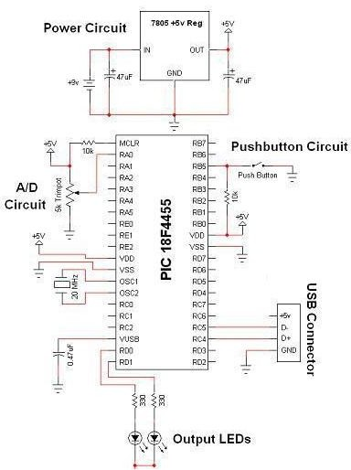

1. **DSL**

DSL is a wired transmission that uses traditional copper telephone lines already installed to homes and businesses. Availability and speed of DSL service may depend on the distance from a home or business to the closest broadband- equipped telephone company central office or telephone exchange.

# **Specifications:**

* Range

The [bit rate](https://en.wikipedia.org/wiki/Bit_rate) of consumer DSL services typically ranges from 256 kbit/s to over 100 Mbit/s in the direction to the customer ([downstream](https://en.wikipedia.org/wiki/Downstream_(networking))), depending on DSL technology, line conditions, and service- level implementation. In general, the maximum range for DSL without a repeater is 5.5 km (18,000 feet). As distance decreases toward the telephone company office, the data rate increases. The typical speed for a DSL connection is 6 Mbps

* Modulation

Modulation is the method the modem communicates with the DSLAM (server). Several Modulation techniques are used by various kinds of DSL, although these are being standardized by the International Telecommunication Union ( [ITU](https://whatis.techtarget.com/definition/International-Telecommunication-Union-ITU) ). Different DSL modem makers are using either Discrete Multitone Technology ( [DMT](https://searchnetworking.techtarget.com/definition/discrete-multitone) ) or Carrierless Amplitude Modulation ( [CAP](https://whatis.techtarget.com/definition/carrierless-amplitude-phase-CAP) ).

* Signaling

Voice signals travel over phone lines at frequencies ranging from 0 kHz to 4 kHz. Standard modems use the same frequencies, but DSL uses frequencies between 25 kHz and 1 MHz. These signals are then translated by a Digital Subscriber Line Access Multiplexer (DSLAM) located at the phone company's nearest central office.

# **Scalability**

DSL Internet service only works over a limited physical distance and remains unavailable in many areas where the local telephone infrastructure does not support DSL technology. The service is not available everywhere. The connection is faster for receiving data than it is for sending data over the Internet.

# **Schematic View**

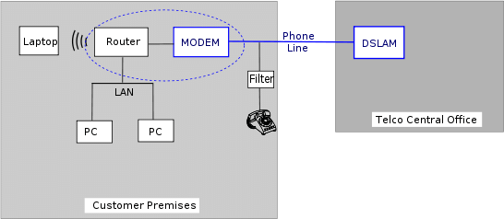

1. **Ethernet**

The Ethernet physical layer is the physical layer functionality of the Ethernet family of computer network standards. The physical layer defines the electrical or optical properties of the physical connection between a device and the network or between network devices. It is complemented by the MAC layer and the logical link layer.

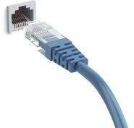

The Ethernet physical layer has evolved over its existence starting in 1980 and encompasses multiple physical media interfaces and several orders of magnitude of speed from 1 Mbit/s to 400 Gbit/s. The physical medium ranges from bulky coaxial cable to twisted pair and optical fiber with a standardized reach of up to 40 km. In general, network protocol stack software will work similarly on all physical layers.

# **Specifications:**

* Range :

Over deployed multimode cabling ethernet supports ranges of between 240 m and 300 m with 400/500 MHz·km modal bandwidth. It also supports 10 km over single-mode fiber.

# **Scalability:**

Ethernet is a family of computer networking technologies commonly used in local area networks (LAN), metropolitan area networks (MAN), and wide area networks(WAN). Ethernet is currently the most widely used technology in enterprise networking. Unfortunately, it is widely acknowledged that Ethernet does not have the scalability to meet the emerging networking needs of large enterprises. Ethernet does not scale well to large networks. The flat MAC address space, whilst having obvious benefits for the user and administrator, is the primary cause of this poor scalability. Ethernet exhibits scalability issues on networks of more than a few thousand devices, such as costly and energy-dense address table logic and storms of broadcast traffic. Ethernet’s inability to handle networks containing loops also presents a scalability problem.

# **Schematic View:**

The ESP32 Ethernet PHY interface is shown in the schematic below. It mainly consists

of three sections:

* The PHY chip or interface
* The 50 MHz oscillator
* Jack and magnetics

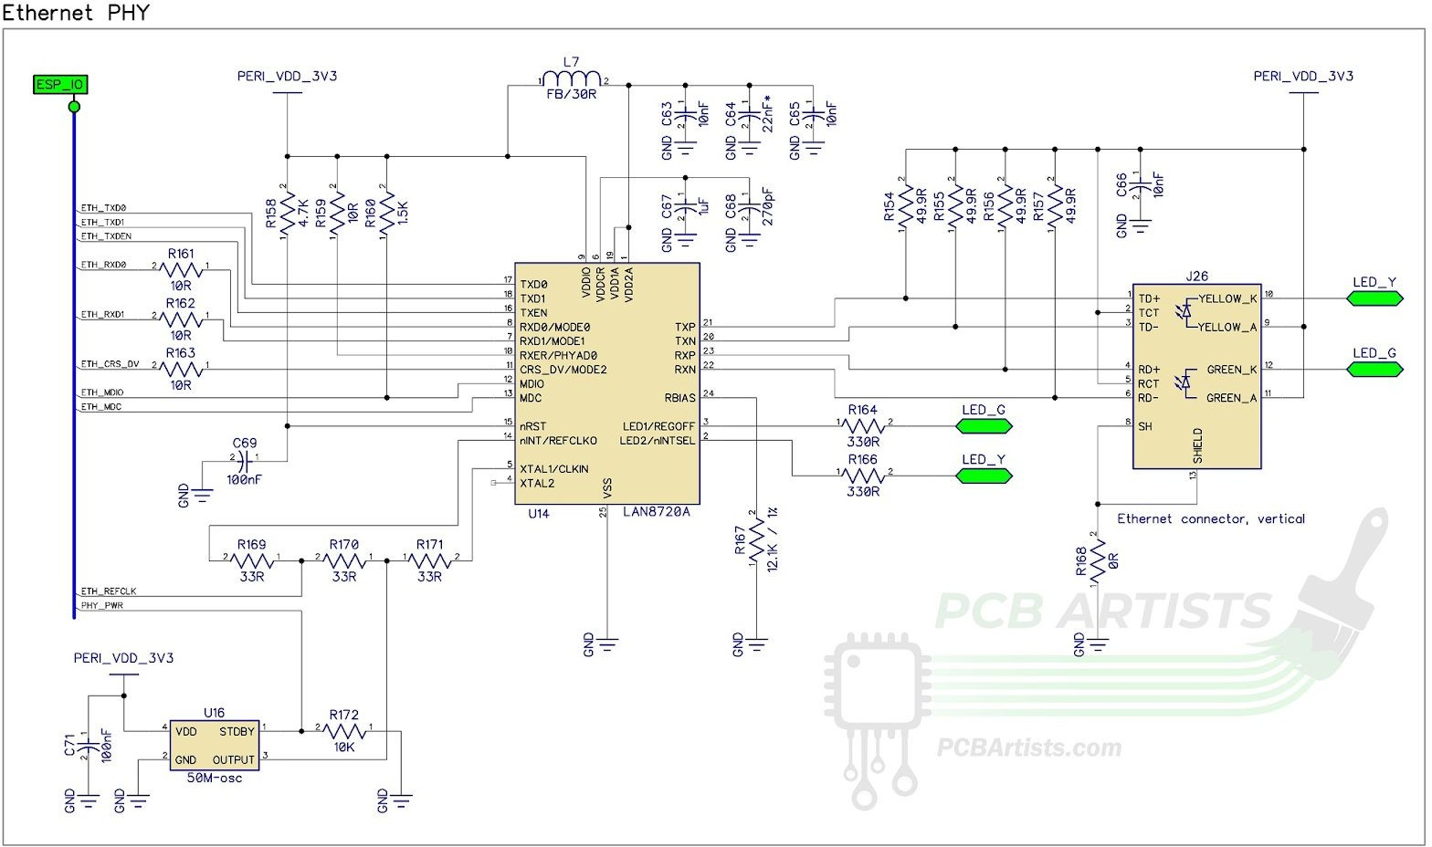

**WIRELESS CONNECTIONS**

1. **Bluetooth**

Bluetooth is a wireless technology standard used for exchanging data between fixed and mobile devices over short distances using short-wavelength UHF radio waves .It was originally conceived as a wireless alternative to RS-232 data cables.

## Specifications

* + - Bluetooth operates at frequencies between 2.402 and 2.480 GHz, or 2.400 and 2.4835 GHz including guard bands
    - 2 MHz wide at the bottom end and 3.5 MHz wide at the top.
    - Range: The effective range between Bluetooth devices is anywhere from more than a kilometer down to less than a meter. Radio spectrum stretches from 30 Hz to 300 GHz. The lower the frequency the longer the range.
    - Modulation: The format originally chosen for Bluetooth in version 1 was Gaussian frequency shift keying, GFSK, however with the requirement for higher data rates two forms of phase shift keying were introduced for Bluetooth 2 to provide the Enhanced Data Rate, EDR capability.

***Gaussian frequency shift keying:***   When GFSK is used for the chosen form of Bluetooth modulation, the frequency of the carrier is shifted to carry the modulation. A binary one is represented by a positive frequency deviation and a binary zero is represented by a negative frequency deviation. The modulated signal is then filtered using a filter with a Gaussian response curve to ensure the sidebands do not extend too far either side of the main carrier. By doing this the Bluetooth modulation achieves a bandwidth of 1 MHz with stringent filter requirements to prevent interference on other channels. For correct operation the level of BT is set to 0.5 and the modulation index must be between 0.28 and 0.35.

***Phase shift keying:***   Phase shift keying is the form of Bluetooth modulation used to enable the higher data rates achievable with Bluetooth 2 EDR (Enhanced Data Rate). Two forms of PSK are used:

* ***π/4 DQPSK:***   This is a form of phase shift keying known as π/4 differential phase shift keying. It enables the raw data rate of 2 Mbps to be achieved.
* ***8DPSK:***   This form of Bluetooth modulation is eight point or 8-ary phase shift keying. It is used when link conditions are good and it allows raw data rates of up to 3 Mbps to be achieved.

## Scalability

Bluetooth technology allows the sharing of voice, data, music, photos, videos, and other information wirelessly between paired devices.  It differs from other radio technologies (mobile phones, radio, and television), in that Bluetooth uses radio waves to transmit over a much shorter distance (164 feet and less, rather than many miles) in what is called a LAN (Local Area Network) or PAN (Personal Area Network)

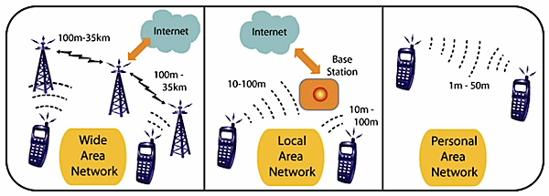

## Schematic View

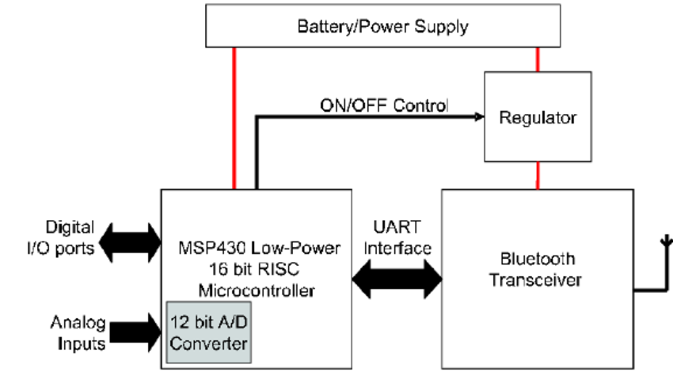

1. **Z Wave**

Z-Wave is a wireless communications protocol used primarily for home automation. It is a mesh network using low-energy radio waves to communicate from appliance to appliance,[1] allowing for wireless control of residential appliances and other devices, such as lighting control, security systems, thermostats, windows, locks, swimming pools and garage door openers.

## Specifications

* + - Communication distance between two nodes is about 30 meters (40 meters with 500 series chip), and with message ability to hop up to four times between nodes, it gives enough coverage for most residential houses.

## Data rates include 9600 bps and 40 kbps, with output power at 1 mW or 0 dBm.

## Range : While Z-Wave has a range of 100 meters or 328 feet in open air, building materials reduce that range. The more line powered devices in your Z-Wave network, the better, as they also act as repeaters to extend the Z-Wave signal.

* + - Modulation : Modulation is frequency-shift keying (FSK) with Manchester encoding.
    - Frequency : It operates at 868.42 MHz in Europe, at 908.42 MHz in the North America and uses other frequencies in other countries depending on their regulations.

## Scalability

Z-Wave can be used within a network (Home Area Network, HAN), and can, therefore, be used to set up all areas of home automation, possibly controlled by a single controller.

A mesh topology allows any node to connect to any other node and allows multiple connections.

The diagram below compares a Wi-Fi network with a Z-Wave network.

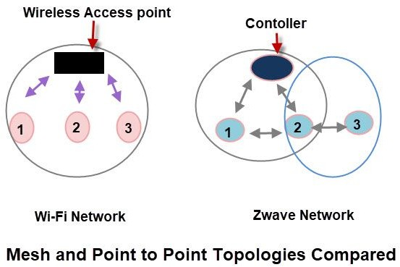

In a Wi-Fi network, all nodes must be in the wireless range of the Wireless Access point, and they can only communicate through the access point.

In Z-Wave, a node must be in the range of another node and can communicate with adjacent nodes. A packet can hop over 4 nodes which means effectively limits the distance between a controller and the farthest node.

A node can forward packets to the adjacent nodes as shown in the diagram above. However to act as a forwarding node the node must be mains powered.

Battery-powered nodes cannot forward packets.

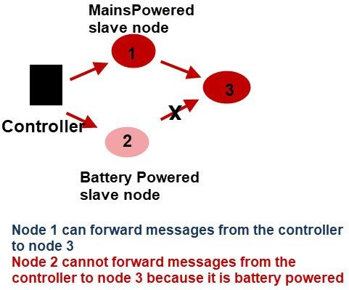

## Schematic View

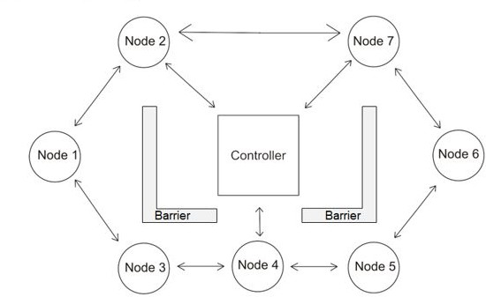

1. **Cellular Networks**

A cellular network or mobile network is a communication network where the last link is wireless. The network is distributed over land areas called "cells", each served by at least one fixed-location transciever, but more normally, three cell sites or base transceiver stations. These base stations provide the cell with the network coverage which can be used for transmission of voice, data, and other types of content. A cell typically uses a different set of frequencies from neighbouring cells, to avoid interference and provide guaranteed service quality within each cell.

When joined together, these cells provide radio coverage over a wide geographic area. This enables numerous portable transceivers to communicate with each other and with fixed transceivers and telephones anywhere in the network, via base stations, even if some of the transceivers are moving through more than one cell during transmission

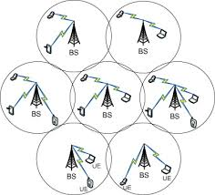.

**Specifications**

* Range: In cities, each cell site may have a range of up to approximately 1⁄2 mile (0.80 km), while in rural areas, the range could be as much as 5 miles (8.0 km). It is possible that in clear open areas, a user may receive signals from a cell site 25 miles (40 km) away.
* Modulation: It uses QAM modulation technique. QAM (quadrature amplitude modulation) is a method of combining two amplitude-modulated (AM) signals into a single channel, thereby doubling the effective bandwidth. QAM is used with pulse amplitude modulation (PAM) in digital systems, especially in [wireless](https://searchmobilecomputing.techtarget.com/definition/wireless) applications
* Signaling: Cellular signalling networks are formed when different cell signalling pathways interact and are detected by a combination of experimental and computational methods.

**Scalability**

Cellular systems use several radio communications technologies. The systems divide the region covered into multiple geographic areas. Each area has a low-power transmitter or radio relay antenna device to relay calls from one area to the next area.

The most common example of a cellular network is a mobile phone (cell phone) network. A mobile phone is a portable telephone which receives or makes calls through a cell site (base station) or transmitting tower. Radio waves are used to transfer signals to and from the cell phone.

**Schematic Diagram**

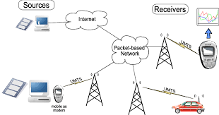

1. **Wifi (**Standard IEEE 802.11**)**

Wi-Fi is a family of wireless network protocols, based on the IEEE 802.11 family of standards, which are commonly used for local area networking of devices and Internet access. Wi-Fi uses multiple parts of the IEEE 802 protocol family and is designed to interwork seamlessly with its wired sibling Ethernet. Compatible devices can network through wireless access points to each other as well as to wired devices and the Internet.

Wi-Fi stations communicate by sending each other data packets: blocks of data individually sent and delivered over radio. As with all radio, this is done by the modulating and demodulation of carrier waves. Different versions of Wi-Fi use different techniques, 802.11b uses DSSS on a single carrier,whereas 802.11a, Wi-Fi 4, 5 and 6 use multiple carriers on slightly different frequencies within the channel (OFDM).

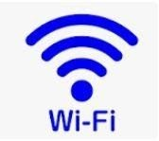

# **Specifications**:

* Range

A wireless network's range can vary wildly depending on the type of network. A standard home network using one wireless router can serve a single-family dwelling, but often not much more.

Business networks with grids of access points can serve large office buildings, and wireless hotspots spanning several square miles have been built in some cities.

Wi-Fi can be used on several types of devices like personal computers, video game console, smart phones, digital camera, tablet computers etc. You can use Wi-Fi to create a hotspot within the range of 20 meters (66 feet).

* Modulation

WiFi systems use two primary radio transmission techniques.

The bit stream is processed with a special coding and then modulated using Quadrature Phase Shift Keying (QPSK). ... 802.11a and g (<=54 Mbps) − The 802.11a and g systems use 64-channel orthogonal frequency division multiplexing (OFDM). 802.11b (<=11 Mbps) − The 802.11b radio link uses a direct sequence spread spectrum technique called complementary code keying (CCK).

# **Scalability :**

Compared to cell phones and similar technology, Wi-Fi transmitters are low power devices. In general, the maximum amount of power that a Wi-Fi device can transmit is limited by local regulations, such as FCC Part 15 in the US. Equivalent isotropically radiated power (EIRP) in the European Union is limited to 20 dBm (100 mW).

To reach requirements for wireless LAN applications, Wi-Fi has higher power consumption compared to some other standards designed to support wireless personal area network (PAN) applications. For example, Bluetooth provides a much shorter propagation range between 1 and 100m[74] and so in general have a lower power consumption. Other low-power technologies such as ZigBee have fairly long range, but much lower data rate. The high power consumption of Wi-Fi makes battery life in some mobile devices a concern.

# **Schematic View:**

ESP8266 has powerful on-board processing and storage capabilities that

allow it to be integrated with the sensors and other application-specific devices through its GPIOs with minimal development up-front and minimal loading during runtime. Its high degree of on-chip integration allows for minimal external circuitry, and the entire solution, including the front-end module, is designed to occupy minimal PCB area. ESP8266 Serial Wifi Wireless Transceiver Module is suitable for Uno, Mega 2560, and Nano.

1. **Zigbee**

Zigbee is an IEEE 802.15.4-based specification for a suite of high-level communication protocols used to create personal area networks with small, low-power digital radios, such as for home automation, medical device data collection, and other low-power low-bandwidth needs, designed for small scale projects which need wireless connection. Hence, Zigbee is a low-power, low data rate, and close proximity (i.e., personal area) wireless ad hoc network.

# **Specification:**

* Range

Its low power consumption limits transmission distances to 10–100 meters line-of-sight, depending on power output and environmental characteristics. Zigbee devices can transmit data over long distances by passing data through a mesh network of intermediate devices to reach more distant ones. Zigbee is typically used in low data rate applications that require long battery life and secure networking (Zigbee networks are secured by 128 bit symmetric encryption keys.) Zigbee has a defined rate of 250 kbit/s, best suited for intermittent data transmissions from a sensor or input device.

* The Zigbee standard operates on the IEEE 802.15.4 physical radio specification and operates in unlicensed bands including 2.4 GHz, 900 MHz and 868 MHz.
* Modulation

The modulation techniques also vary according to the band in use. Direct sequence spread spectrum (DSSS) is used in all cases. However for the 868 and 915 MHz bands the actual form of modulation is binary phase shift keying. For the 2.4 GHz band, offset quadrature phase shift keying (O-QPSK) is employed.

# **Scalability:**

The technology defined by the Zigbee specification is intended to be simpler and less expensive than other wireless personal area networks (WPANs), such as Bluetooth or more general wireless networking such as Wi-Fi. Applications include wireless light switches, home energy monitors, traffic management systems, and other consumer and industrial equipment that require short-range low-rate wireless data transfer.

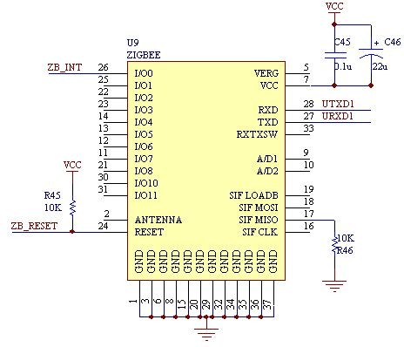**Schematic Diagram:**

REFERENCES:

Coaxial Cable

* + <https://www.ppc-online.com/blog/what-is-coaxial-cable-and-how-is-it-used>
  + <https://www.ciscopress.com/articles/article.asp?p=31276&seqNum=2#:~:text=Coaxial%20cable%20can%20be%20cabled,to%20500m%20(1640.4%20feet).>

Twisted Pair Cable

* <https://en.wikipedia.org/wiki/Twisted_pair>
* <https://networkencyclopedia.com/shielded-twisted-pair-stp-cabling/#:~:text=STP%20Cabling%20is%20twisted%2Dpair,themselves%20are%20wrapped%20in%20foil.>
* <https://www.fiberoptics4sale.com/blogs/archive-posts/95046918-what-is-unshielded-twisted-pair-utp-cable>

Fiber Optics Cable

* <https://community.fs.com/blog/the-difference-between-fiber-optic-cable-twisted-pair-and-cable.html>
* <https://www.fastmetrics.com/how-fast-is-fiber-optic-internet.php#:~:text=Fiber%20optics%3A%20Up%20to%2010,300%20million%20bits%20per%20second).>

USB

* <https://en.wikipedia.org/wiki/USB>
* [https://www.cmd-ltd.com/advice-centre/usb-chargers-and-power-modules/us b-and-power-module-product-help/usb-data-transfer-guide/](https://www.cmd-ltd.com/advice-centre/usb-chargers-and-power-modules/usb-and-power-module-product-help/usb-data-transfer-guide/)

DSL

* <https://www.geeksforgeeks.org/digital-subscriber-line-dsl/>
* <https://broadbandforum.co/t/154058/>
* <https://en.wikibooks.org/wiki/Communication_Networks/DSL>

Ethernet

* <https://en.wikipedia.org/wiki/Ethernet_physical_layer>
* <https://searchnetworking.techtarget.com/definition/Ethernet>

Bluetooth

# <https://en.wikipedia.org/wiki/Bluetooth>­­

# <https://www.bluetooth.com/learn-about-bluetooth/bluetooth-technology/range/>

# <https://www.electronics-notes.com/articles/connectivity/bluetooth/radio-interface-modulation-channels.php>

# <https://hearinghealthmatters.org/waynesworld/2013/bluetooth-101-part-ii/>

# ­­­

# Z-wave

# <https://en.wikipedia.org/wiki/Z-Wave#Network_setup,_topology_and_routing>

# <https://stevessmarthomeguide.com/z-wave-basics/>

# <https://www.z-wave.com/faq>

# <https://www.electronicdesign.com/technologies/communications/article/21796052/whats-the-difference-between-zigbee-and-zwave#:~:text=Z%2DWave%20uses%20the%20Part,s%20and%2040%20kbits%2Fs.>

# Cellular Network

# <https://en.wikipedia.org/wiki/Cellular_network#:~:text=A%20cellular%20network%20or%20mobile,sites%20or%20base%20transceiver%20stations.>

# <https://www.electronicdesign.com/technologies/communications/article/21798737/understanding-modern-digital-modulation-techniques#:~:text=GSM%20cell%20phones%20widely%20use,in%20a%20200%2DkHz%20channel.&text=A%20very%20popular%20digital%20modulation,2).>

# <https://www.nature.com/subjects/cellular-signalling-networks#:~:text=Cellular%20signalling%20networks%20are%20formed,of%20experimental%20and%20computational%20methods>.

# Wifi

# <https://en.wikipedia.org/wiki/Wi-Fi>

# <https://www.tutorialspoint.com/wi-fi/wifi_radio_modulation.htm#:~:text=WiFi%20systems%20use%20two%20primary%20radio%20transmission%20techniques.&text=The%20transmitter%20encodes%20the%20bit,%2C%20or%2064%2DQAM).>

# Zigbee

# <https://www.electronics-notes.com/articles/connectivity/zigbee/what-is-zigbee-technology-tutorial.php#:~:text=The%20modulation%20techniques%20also%20vary,O%2DQPSK)%20is%20employed.>

# <https://en.wikipedia.org/wiki/Zigbee>

# CONCLUSION:

I studied the different types of wired and wireless connections in terms of their specifications, scalability with respect to their application in types of network architectures and a schematic view of the connection.